Starbucks Business Intelligence Dashboard
An interactive Power BI Business Intelligence Dashboard built using the Starbucks Beverage Nutrition dataset to analyze beverage categories, nutritional composition, and executive-level business insights. The dashboard enables stakeholders to monitor key performance indicators (KPIs), compare product categories, and explore nutritional trends through interactive visualizations.

Project Overview
This project demonstrates the development of a multi-page Business Intelligence dashboard using Power BI. The objective was to transform raw beverage nutrition data into meaningful insights that support business decision-making.The dashboard focuses on nutritional analysis, category comparison, executive reporting, and interactive data exploration using modern Business Intelligence techniques.

Business Objectives
- Analyze nutritional information across Starbucks beverages.
- Compare beverage categories based on calories, sugar, protein, and caffeine.
- Identify high-calorie and high-caffeine beverages.
- Monitor business KPIs using interactive dashboards.
- Present executive-level insights for strategic decision-making.

Technologies Used
| Tool | Purpose |
| Power BI Desktop | Dashboard Development |
| Power Query | Data Cleaning & Transformation |
| DAX | KPI Calculations & Measures |
| Microsoft Excel | Data Source |
| Data Visualization | Business Reporting |
Dashboard Structure
Page 1- Overview Dashboard
The Overview page provides a high-level summary of the Starbucks beverage dataset.
Features
- Executive KPI Cards
- Calories by Beverage Category
- Beverage Category Distribution
- Top 10 Highest-Calorie Drinks
- Calories vs Average Caffeine Analysis
- Interactive Filters

Page 2 – Nutrition Analysis
The Nutrition Analysis page focuses on detailed nutritional comparisons across beverages.
Features
- Nutrition KPI Cards
- Calories vs Sugar Scatter Plot
- Top Protein-Rich Beverages
- Average Caffeine by Beverage Category
- Nutrition Details Table
- Dynamic Filtering

Page 3 – Executive Insights
The Executive Insights page presents business-focused visualizations for management reporting.
Features
- Executive KPI Summary
- Calories Distribution by Category
- Beverage Category Share
- Top 10 Highest Caffeine Drinks
- Executive Detail Table
- Business Insight Panel
Key Performance Indicators (KPIs)
The dashboard includes the following KPIs:
- Total Drinks
- Average Calories
- Average Sugar
- Average Protein
- Average Caffeine
- Average Total Fat

Visualizations Used
- KPI Cards
- Clustered Column Chart
- Clustered Bar Chart
- Donut Chart
- Scatter Plot
- Line & Staked Column Chart
- Interactive Table
- Slicers
Key Business Insights
- Coffee beverages contain the highest average caffeine levels.
- Frappuccino beverages contribute significantly to total calories and sugar.
- Tea-based beverages generally offer lower-calorie alternatives.
- Protein-rich beverages are concentrated within a limited number of categories.
- Beverage preparation methods influence nutritional composition and should be considered during product analysis.
Project Structure
Starbucks-Business-Intelligence-Dashboard/
│
├── Dashboard/
│ └── Starbucks_Business_Intelligence.pbix
│
├── Data/
│ └── starbucks.csv
│
├── Images/
│ ├── Overview.png
│ ├── Nutrition_Analysis.png
│ └── Executive_Insights.png
│
└── README.md

Overview Dashboard
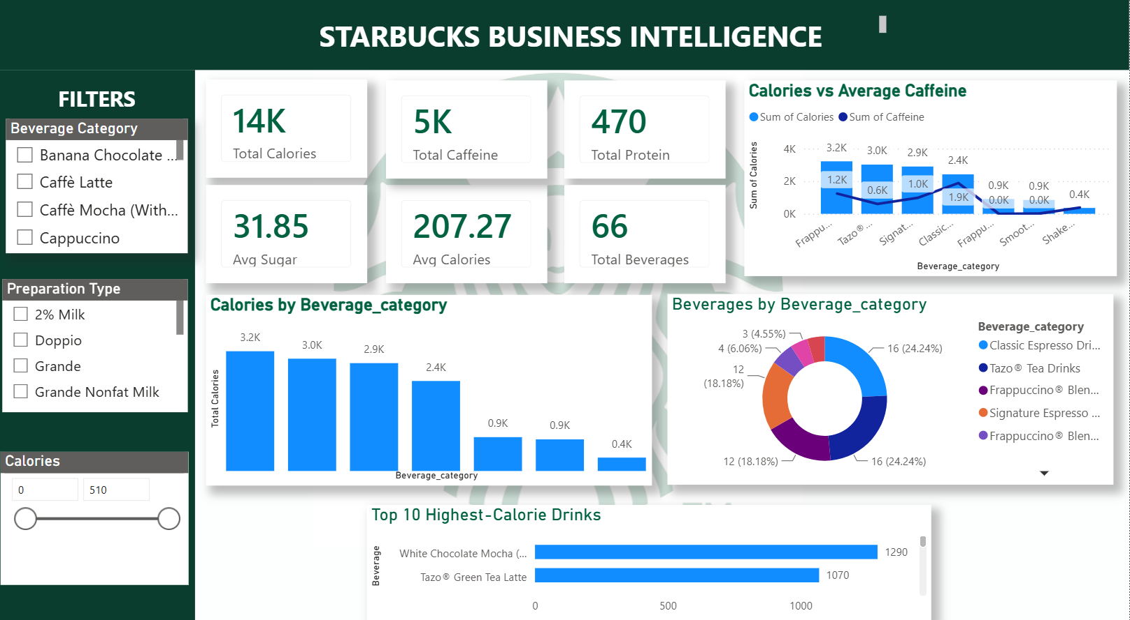

Nutrition Analysis Dashboard
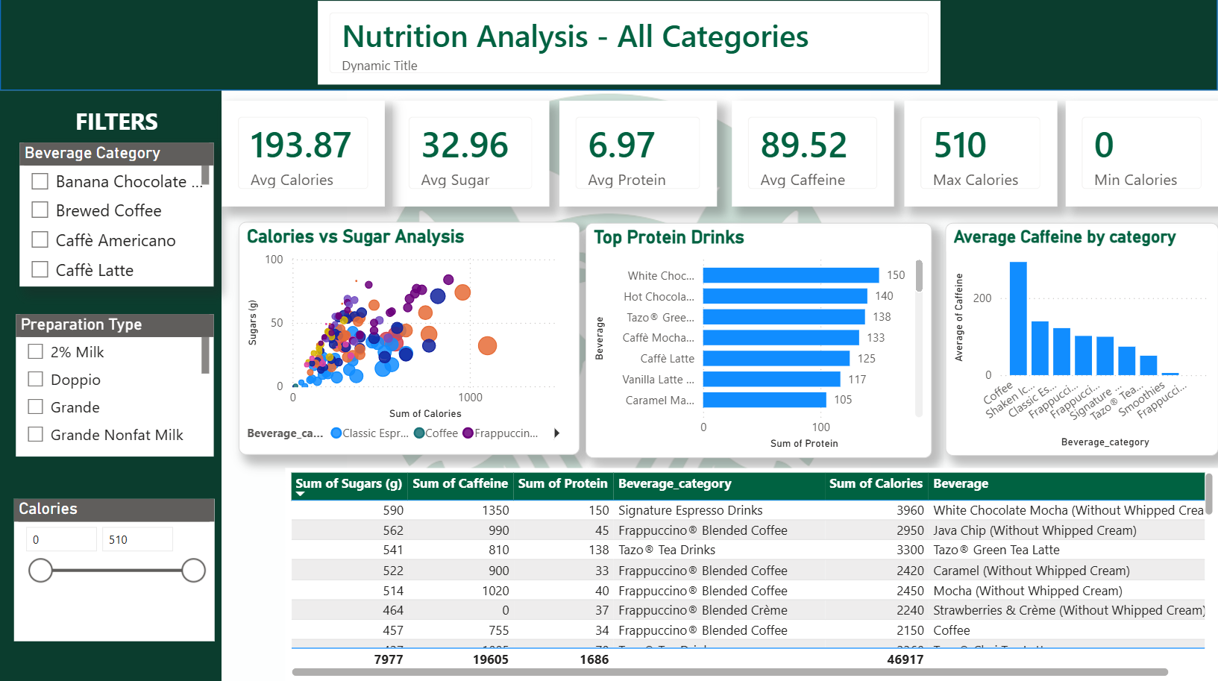

Executive Insights Dashboard

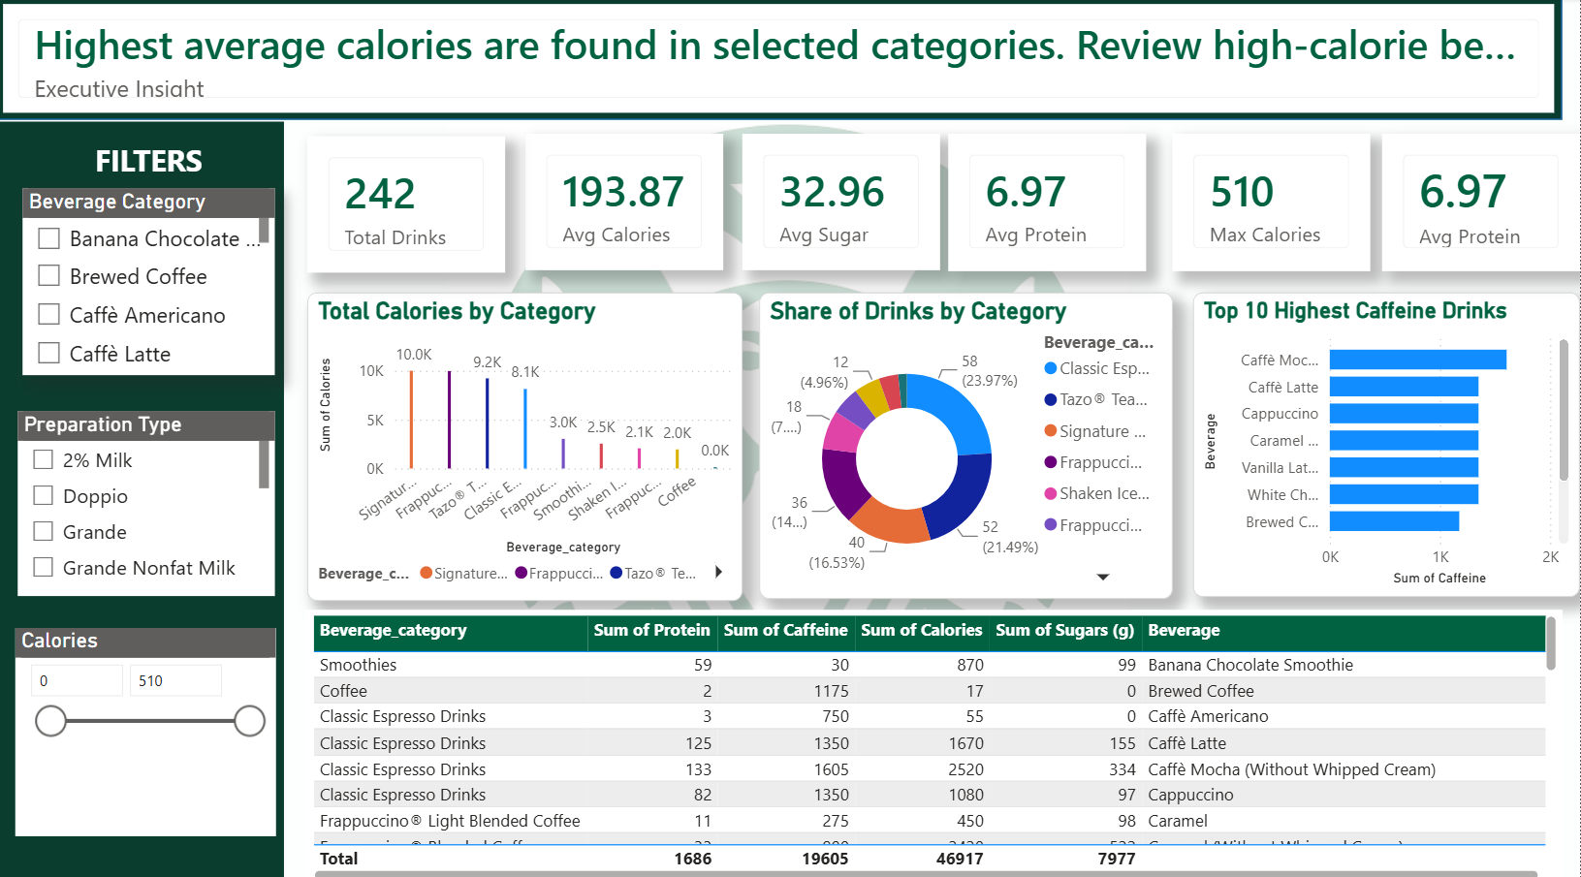

Skills Demonstrated
- Business Intelligence
- Dashboard Development
- Data Visualization
- Data Cleaning
- Power Query
- DAX
- KPI Design
- Interactive Reporting
- Business Analytics
- Executive Reporting
Learning Outcomes
Through this project, I gained practical experience in:
- Designing professional Business Intelligence dashboards.
- Developing reusable DAX measures.
- Creating interactive reports using slicers and cross-filtering.
- Building executive-level reports for business users.
- Applying visualization best practices to improve decision-making.
Future Enhancements
Potential improvements for future versions include:
- Sales and Revenue Analysis
- Customer Segmentation
- Predictive Analytics using Python
- Power BI Service Deployment
- Real-time Data Refresh

👩‍💻 Author
Vishakha Dhole
Aspiring Data Analyst | Power BI | SQL | Python | Excel

GitHub:- https://github.com/vishakhadhole2905-star
LinkedIn:- www.linkedin.com/in/vishakha-dhole-154625342

